Building an application

Flow diagram; this shows the logic and how the program will run.

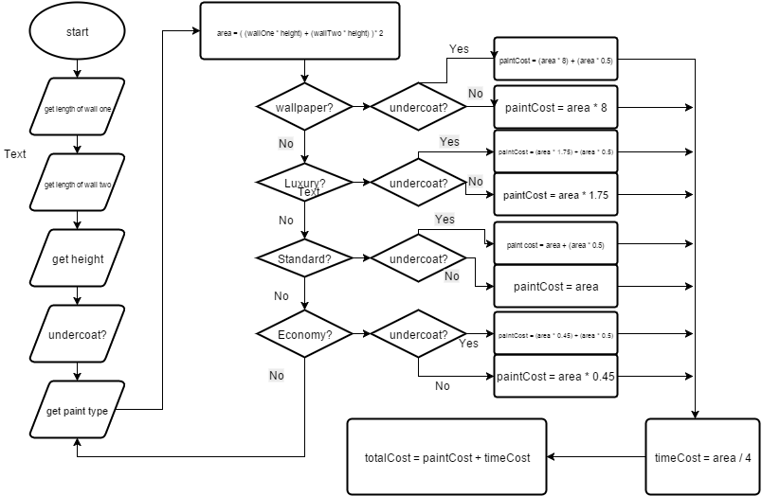

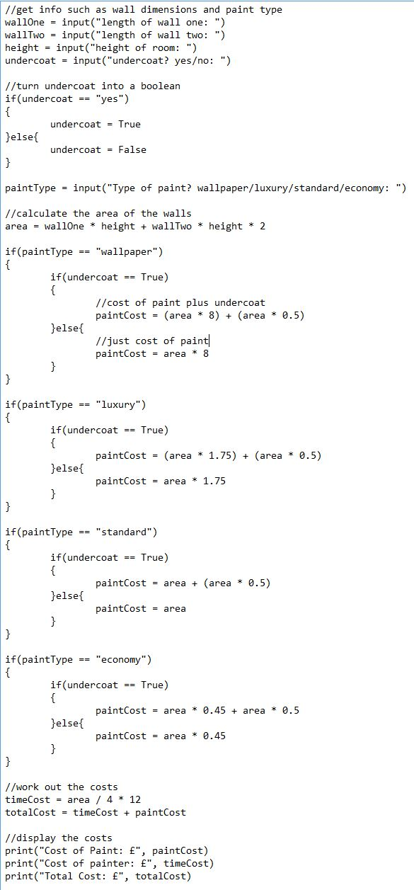

Actual code – the finished application that can be used. I have written it in python.

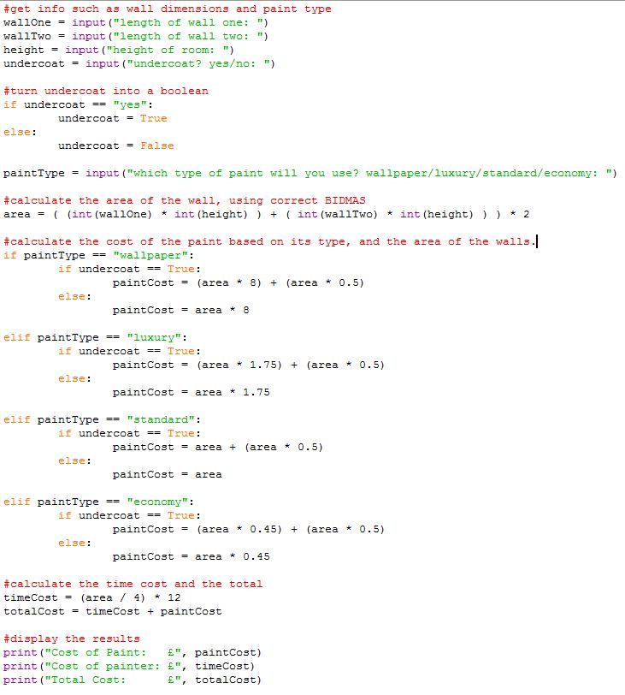

And the output of the program.

